How to set up the Zoom application

1. Download Visual Studio 2019 (VS) community edition. It is free.
2. Open the Zoom project using VS just downloaded.
3. Update the project via NuGet if necessary.

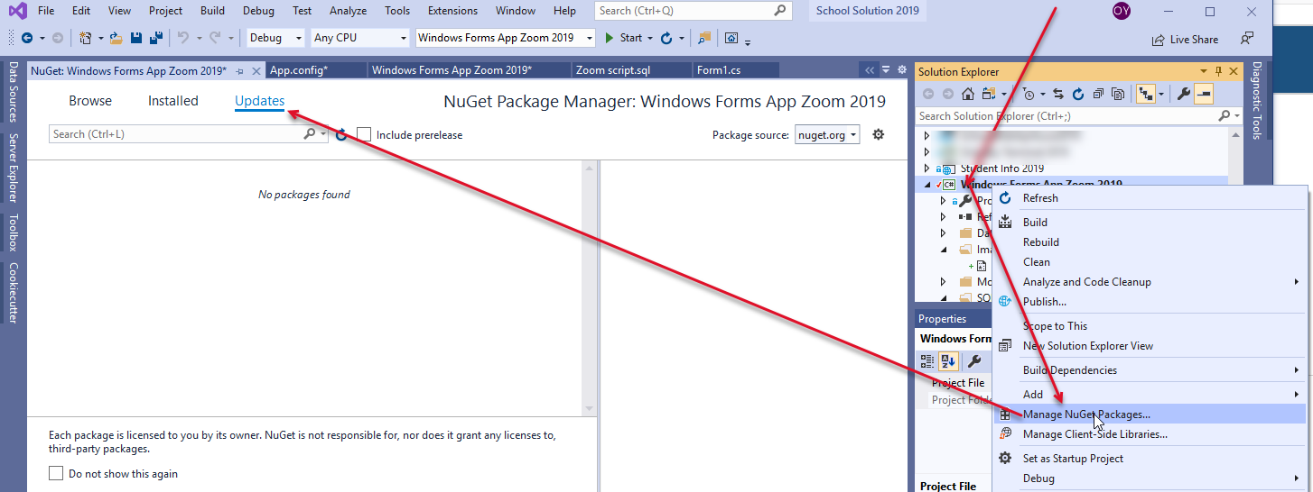

1. Find an SQL script in SQLScripts folder in the project and execute it using SQL management studio against your target database. Make sure if the schema name in the script is yours. The default schema for this application is zoom. The script will create objects as well as their necessary lookup data too.

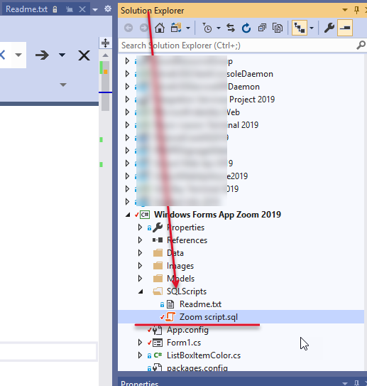

1. If your db schema is not zoom, update the key value of the app db schema name in App.config file.

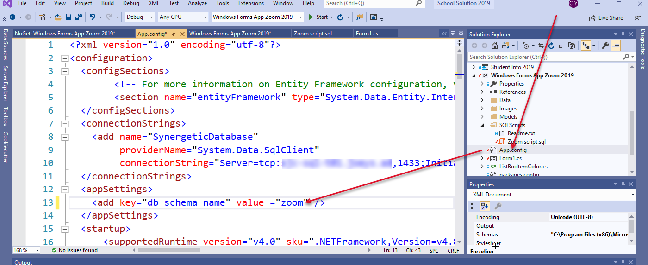

1. Update the SQL connection string with yours in App.config file.

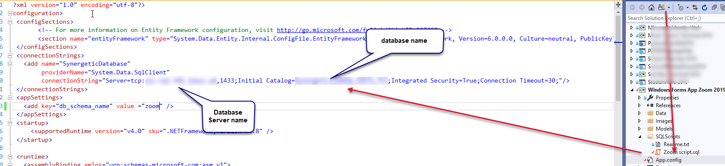

1. Test the project to see if it works in your IT environment.

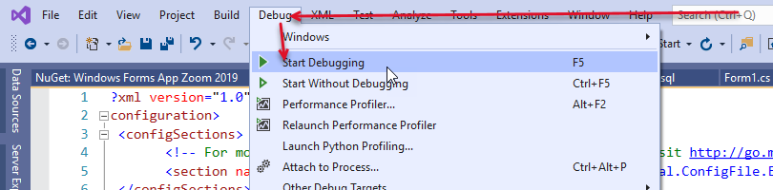

1. If it works, publish it. Users can launch the application from the link. Make sure the target user must have appropriate permission on the db objects.

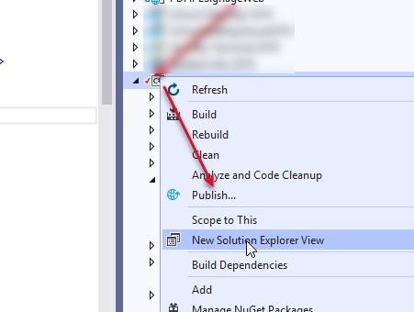

1. Happy coding.

How to use the app

1. Add some staff or your account to the Synergetic tag list. For testing, it is a good idea to use your Synergetic ID.
2. Launch the application via the installed point or via VS.
3. Click >> button to display the configuration screen.

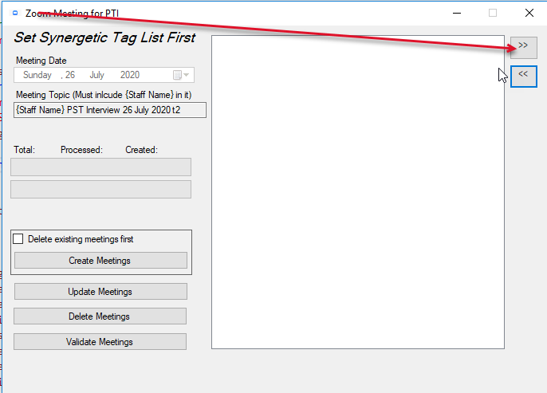

1. Update configuration values if necessary. You can find details of parameters for ZOOM APIs at <https://marketplace.zoom.us/docs/api-reference/zoom-api/meetings/meeting>

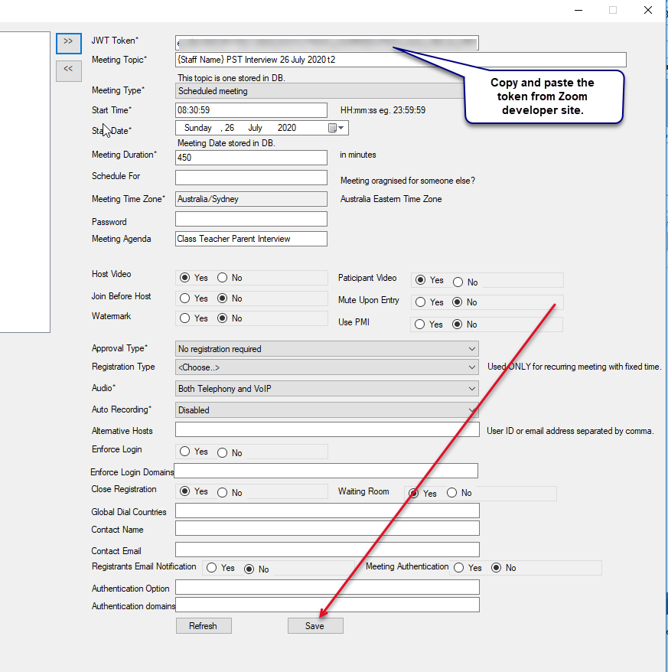

1. You can find your jwt token in the Zoom developer market place just in case.

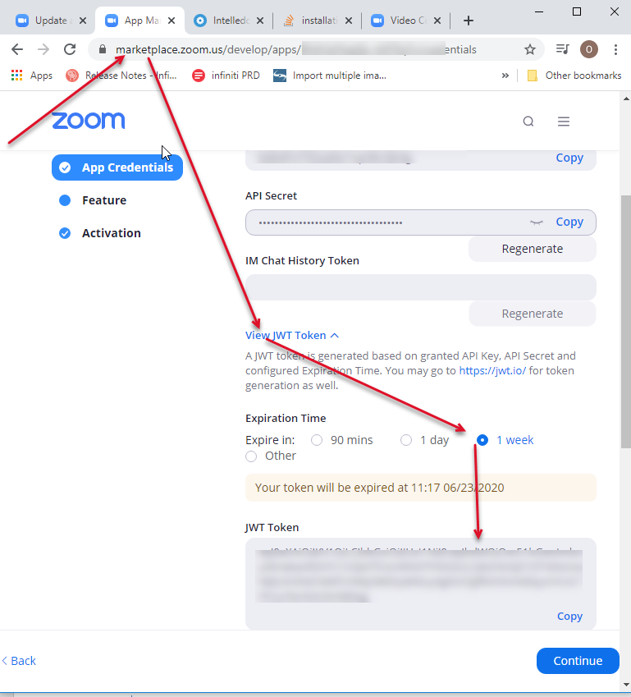

1. Click << if you like to close the configuration area.

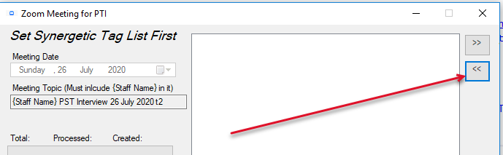

1. You should be able to create, update or delete meetings. You could update these functions to update PTI in Synergetic directly. But we don’t use Synergetic PTI.

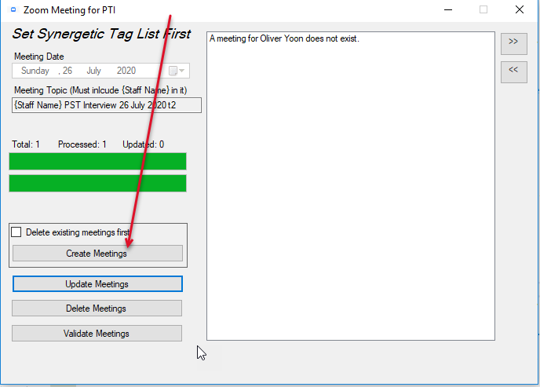

1. You can manipulate the data in Synergetic database if necessary.

Select * FROM [Synergetic_AUNSW_JOEYS_TST].[zoom].[uZoom_Users]